Software Requirements Specification
For
VOCAL
Version 1.0 approved
Prepared by : Raja Aneeq
Saad Masood
feb 27, 2012
Table of Contents
Table of Contents ii
Revision History ii
1. Introduction 3
1.1 Purpose 3
1.2 Document Conventions 3
1.3 Intended Audience and Reading Suggestions 4
1.4 Project Scope 6
1.5 References 7
2. Overall Description 8
2.1 Product Perspective 8
2.2 Product Features 8
2.3 User Classes and Characteristics 9
2.4 Operating Environment 9
2.5 Design and Implementation Constraints 11
2.6 User Documentation 12
2.7 Assumptions and Dependencies 12
3. System Features 13
3.1 System Feature 1 13
3.2 System Feature 2 . 16
4. External Interface Requirements 21
4.1 User Interfaces 21
4.2 Hardware Interfaces 22
4.3 Software Interfaces 22
4.4 Communications Interfaces 22
5. Other Nonfunctional Requirements 25
5.1 Performance Requirements 25
5.2 Safety Requirements 25
5.3 Security Requirements 25
5.4 Software Quality Attributes 26
6. Other Requirements 26
7. References ….……………………………………………………………………………28
Appendix A: Glossary I
Appendix B: Issues List III

Revision History
Name | Date | Reason For Changes | Version
Project Team | October 13, 2011 | Initial specification of requirements | 1.0

Introduction

Purpose
A Software Requirements Specification (SRS) document describes a software product and states, in detail, the various types of requirements of that product. It also serves as a formal check list for both the client and the developing organization. Apart from these parties, the testers and developers of any future versions can also use it for reference. The present document is the SRS for VOCAL (Release 1.0). VOCAL will be a mobile based application for mobiles phones sets which use Android and Windows OS. VOCAL will allow users of such mobiles phones to form a social network among themselves. It will provide features of video calling and location tracing, besides maintaining user profiles (as a future enhancement).

Document Conventions

This document uses various terminologies for referring to different technologies, techniques and network components. These are briefly described below. The reader can find more detailed information from the given references.

CODEC (Coder-Decoder). CODEC is a type of software for encoding (compressing) and decoding (decompressing) digital media files i.e. songs or videos. Different available media players are used for creating and then playing such digital media files. Windows Media Player 12 is one popular CODEC.

EDGE (Enhanced Data Rate for GSM Evolution). EDGE is a mobile phone technology of GPRS family which is standardized by 3GPP (described below). It allows a high bit-rate data transmission (three time better capacity and performance as compared to GSM / GPRS connections). This is achieved through sophisticated methods used for data compression and transmission. A benefit of EDGE is that is conserves the available bandwidth by loading it with lighter (highly compressed) data.

GPL (General Public License). The GNU General Public License (GNU GPL or simply GPL) is the most widely used free software license, originally written by Richard Stallman for the GNU Project.

GPRS (General Packet Radio Service). It is a standard for wireless communications which runs at speeds up to 15 kilobits per seconds (kbps). It supports a wide range of bandwidths and is suited for sending small bursts of data e.g. emails and web browsing content, as well as data of large volume. This standard is now maintained (specified) by 3GPP.

GSM (Global System for Mobile Communication). It is a standard for wireless communications which runs at speeds up to 9.6 kbps. It was developed for the 2nd generation (2G) digital cellular networks which replaced the old analog AMPS technology. Many mobile phone sets still work on this technology, although it has been succeeded by the 3G Technology.

HTTP (Hyper Text Transfer Protocol).^{[1]} HTTP is the most widely used network protocol in the World Wide Web. It is a stateless, request response protocol in a client – server computer architecture.^{[2]} Through HTTP request and response messages, web content is exchanged between client and server systems.^{[3]}

LGPL (Lesser General Public License). LGPL is a free software license published by the Free Software Foundation

Media Server. It is a dedicated machine or software meant for storing and sharing media (video) content to client machines. It provides real time media processing functions.^{[4]} Hence, it is used to streaming video between two nodes. Usually it is web server of a large internet website but it may even be a specialized application which enable users to remotely access media files over the internet.

NAT (Network Address Translator). NAT is a method by which IP addresses are mapped from one realm to another. NAT is necessitated due to growing shortage of IP addresses and scaling of routing. An advantage of NAT is that the IP addresses of systems within a particular domain, can be used by several other systems inside another domain. It is a router function so a dedicated router is configured to replace the IP address (in the headers of outgoing messages of systems inside a domain) with that of its own IP, and likewise for the incoming traffic.
RTP Real Time Transport Protocol). RTP defines a standardized packet format for delivering audio and video over IP networks. RTP is used extensively in communication and entertainment systems that involve streaming media, such as telephony, video teleconference applications and web-based push-to-talk features.

SIP. Session Initiation Protocol.

UML. Unified Modeling Language.

3G. 3RD Generation Mobile Telecommunication.

3 GPP(3RD Generation Partnership Project). 3GPP is a collaboration between different groups for the purpose of preparing, approving and maintaining Technical Specifications and Technical Reports for GPRS, 3G, EDGE and the later technologies of mobile phones.^{[7]}

Intended Audience and Reading Suggestions

General Suggestions
This document forms a contractual reference for the client and the development team. Due to this nature of the document, it is intended to be referred primarily by the development team, the client and all other personnel committed to project supervision / coordination. It will also be a useful reference material for all the people related to computer software; particularly those who intend enhancing some feature of VOCAL. This document includes UML diagrams and details / description of some purely technical aspects of the product, so it is expected that majority readers of this document readers have computer programming background.

System Maintenance Personnel
Following reading is suggested for this reader class:-

Section 3

Section 4

Section 5

Service Providers
Service providers (if they are interested in formally launching this application) will need to at least read the following parts of this document:-
- Section 2

End Users

Following parts of this SRS will be useful for the end-users:

Section 1.3.1

Section 2.1

Section 2.2

Project Scope

Project Description

The project aims at developing a mobile application (Android and Windows based) that will allow users to communicate through video calls and track one another’s location (specified area using GPS) on Google maps and are to form a social network. This social network will have following features:-

Displaying blips on locations of other application users within 8 km radius, keeping the default radius for display at 1km.

Video calling.

Location acquisition using GPS.

User profile i.e. name, age and picture.

Messages. (Extended Goal)

Settings. (Extended Goal)

Business Objectives and Success Criteria

VOCAL will be an attractive application that will efficiently fulfill its claimed functionalities by quick access and updates. Success will be measured by the number of users who choose to register to this application and by encountering lesser number of bugs after deployment. Since it is not intended to be kept open-source, another important metric of success will be its being purchased by cellular companies e.g. Mobilink, Ufone. If this materializes, financial benefit is expected.

Similar applications are already available in iPhones but the developers are hopeful of success because it will offer solution with added features on relatively more economical mobile phone sets. It is also expected to attract users by offering a new platform for social networking in which users will take interest in connecting due to their location. The user population is expected to be particularly interested in knowing where their chat / video-call partners are located.

Project Vision

VOCAL is intended for the present and potential users of Android / Windows based cellular phones (in particular) and all cellular phone users (in general) who are interested in video chatting with their friends. The target market will further include users who like to broaden their friend circle by spotting other users of this application located within a specified radius. VOCAL is a mobile application for Android & Windows based phones that will provide video call feature on more economical devices as compared to the expensive smart phones like iPhone. Moreover, the feature of location tracking will add another exciting experience. Unlike Android based version of Skype and a similar service by Apple which are available only on wifi, our solution will provide the same service over Edge and GPRS technologies. Our product is constrained in quality of video due to limitation of bandwidth over wireless medium. Due to this constraint, a lot of compression will be required, which, with the present compression techniques, is not feasible. So it will have to be achieved by reducing the frame rate and image resolution. However, this issue may be addressed with evolving efficient compression algorithms.

Project Scope

Ser | Project Scope Includes | Project Scope Does Not Include
1. | Development of Design Models
2. | Development of working mobile Android & Windows applications. | Development of a similar version of the application for other OS / platforms.
3. | Providing the feature of video call. | Providing the features of instant messaging and video messaging.
4. | Using a SIP Server for connection establishment.
6. | Locating, tracking and updating other users of VOCAL through Google Map.

References
- Project Proposal for Video Call & Location (VOCAL) Version 1.0 Approved (June 15, 2011).
- Project Charter for Video Call & Location (VOCAL) Version 1.0 Approved (September 30, 2011).

Overall Description

Product Perspective
VOCAL will be a new product. The conception of it’s idea was certainly prompted by a similar application (Face), which is offered on iPhones phones. Since iPhones are much expensive, Face is used by a limited number of users only. VOCAL will offer a new experience to mobile phone users which will be entertaining and different at the same time. Therefore, this SRS is meant for Version 1.0 of VOCAL.
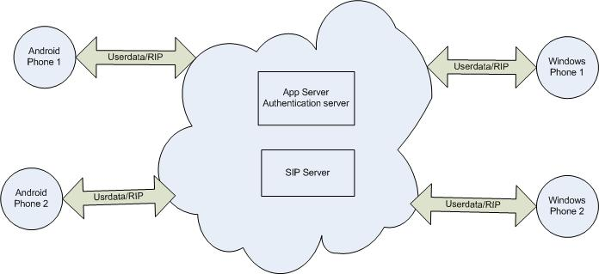

Figure 2.1 - VOCAL WITHIN THE INTERNET CLOUD

Product Functions

Key features of this product are as listed below:-

User Authentication. A user will first have to get itself authenticated in order to be logged in to the system. User authentication will be on base of user-name, their e-mail addresses and passwords.

Video Call

User can make video call to any other VOCAL user who is online and who lies within the covered radius.

Displaying own location and that of others by using Google maps.

Sending requests to connect for video call.

Accepting and ignoring requests.

Creating and Maintaining User Profiles

Changing personal details (name, age).

Changing profile picture.

User Classes and Characteristics
The target end-users of the VOCAL are Android and Window’s mobile users. It can be consulted by mobile application developers, mobile service providers and even the end users.

System Administrator
This class of users must to know the system’s technical aspects and should have a thorough understanding of working of the system. System Administrator shall have access to all the services and shall also be responsible for the maintenance.

End-users
Most end users will not have much technical background of computer science. In order to use this application they should already be familiar with using internet from their mobiles sets. They could be of any age, race, may have different educational backgrounds.

Operating Environment
These are the system components.

Component Name | Description | OS
Authentication / Web Server | Used for logging in / logging out and for running the VOCAL Server Application. | Windows Server 2003 / 2008
SIP Server | Use for video streaming | Linux / Unix
VOCAL on “Android” | Client Application | Android 2.2
VOCAL on “Windows” | Client Application | Window 6.1

Design and Implementation Constraints
Dimension | Constraint | Factor / Reason for Constraint | Degree of Freedom (Acceptability of Constraint)
Features | Video call will not be possible under all circumstances if signal strength is poor or bandwidth is choked. | Shared bandwidth offered by cellular phone companies and distances from BTS limit the actual bandwidth to be utilized for video streaming. | 30%
Features | The application will not be usable on Apple and other mobile phone sets which do not work on Android or Windows OS. | The application is being developed only for Android and Window based mobile phone sets. | 70%. Since Android phones are already much popular in public.
Quality | Video may have jitters and low quality. | Bandwidth offered by cellular companies is less and it entails greater compression for video streaming. | 50 - 55%
Service | Application will be usable subject to availability of adequate bandwidth. | 3G and Edge coverage is not nationwide. Shared bandwidth is being offered presently and it limits a single user in crowd of other users. | Indigenous compression will solve the issue of required bandwidth to some extent.
Hardware | Comprehensive testing on all types of Windows / Android Phone sets may not be feasible due to a vast variety of models available in the market. | Different models have different design features e.g. screen size / resolution; absence of a secondary camera, which may limit a user from making a video call while watching from the screen. | Testing will have to be done on more popular mobile phone sets / other phone sets with such specifications.
Cost | Android mobile phones are generally expensive. At least three sets of different models / specifications (camera resolution; EDGE / 3G support; processing power) will have to be procured. | For a large user population, mobile set prices need to lie within affordable range. | For the moment, project may be started with only two Windows and two Android phone sets.
Schedule | Time is limited. | Release 1.0 to be available by March 15, 2012, release 1.1 by April 15, 2012. | 2 – 3 weeks margin is kept in completion of releases.

User Documentation
The documentation provided to the final user should be complete and exhaustive in each functionality of the software. Images and examples should come with the function depicted, in order to smooth as much as possible, the acquaintance curve of the user with the product.

System Features

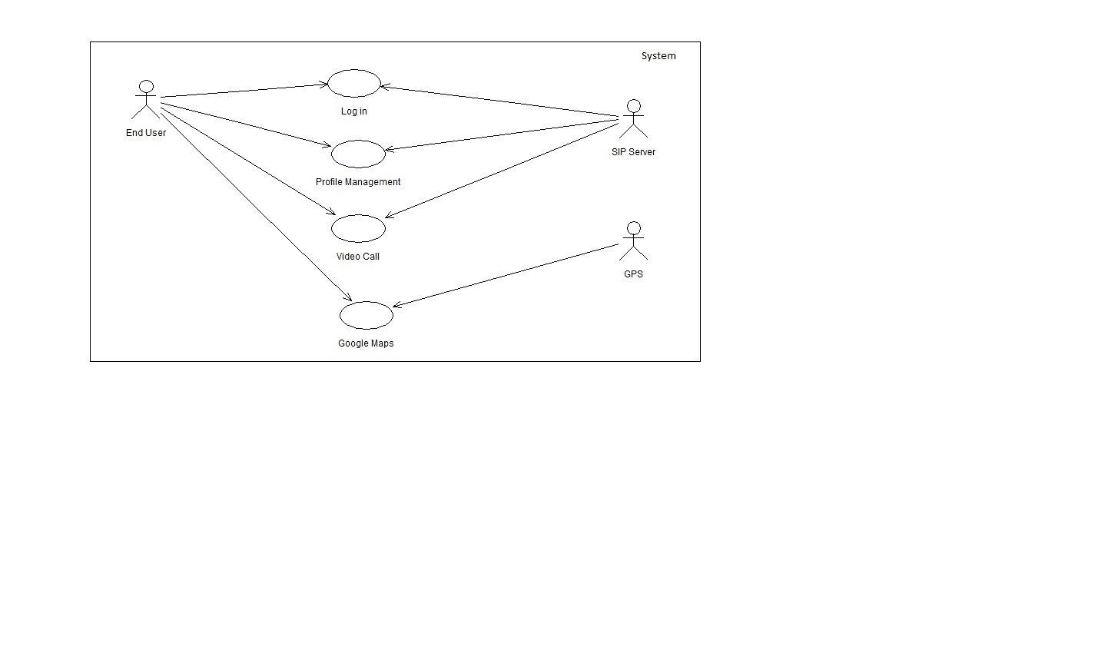
Functional Requirements

Use Case – : Google Maps
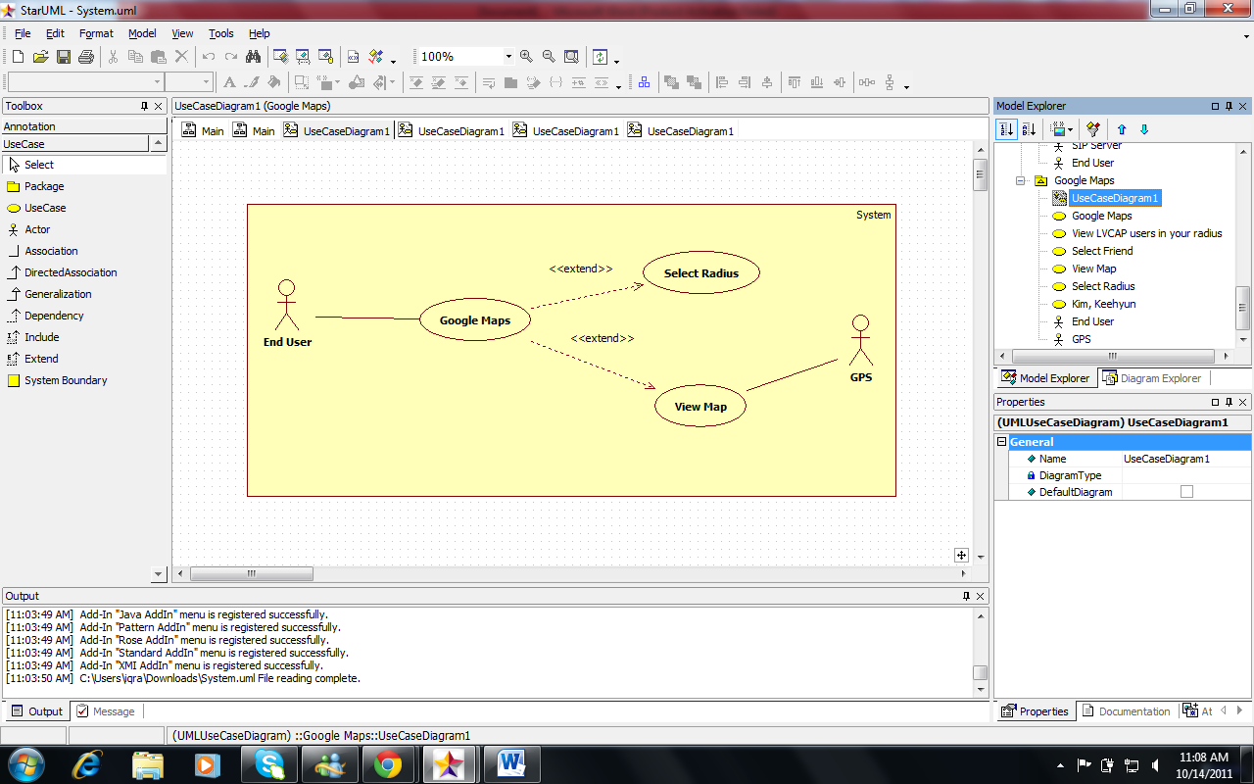

Use Case – s:Profile Management
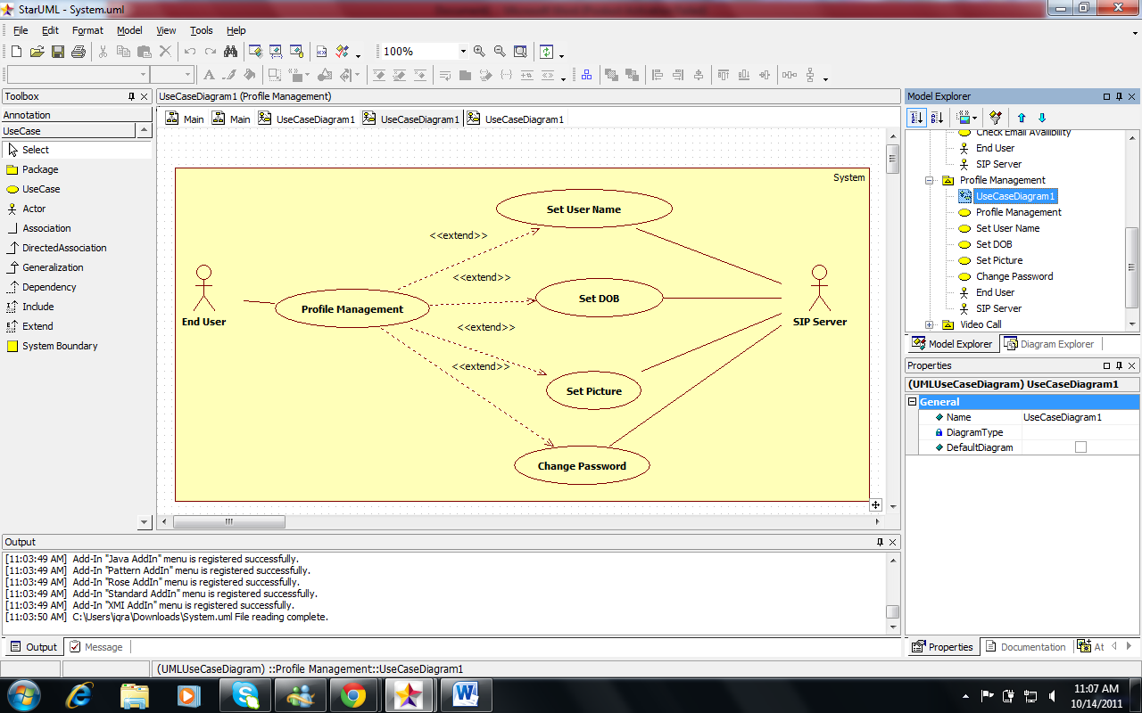
.

Communication Features
Features | Priority
User can receive video call only when he is logged in. | High
User can make video call to one contact at a time. | High
User can quit the call anytime. | High
User can receive call from any VOCAL user. | High
User can send an instant message to one or multiple contacts | Low(Extended goal)
User can receive instant message. | Low(Extended goal)

General Features
Features | Priority
Add a contact. | (Extended goal)
Delete an existing contact. | (Extended goal)
Block / unblock contact. | (Extended goal)
Import contacts | (Extended goal)

3.5 Settings Features
Features | Priority
Edit user profile. | High
Control audio volume. | High
Change video size / resolution / quality based both on user preferences and on bandwidth availability. It will be possible to change it during a video call. | Low(Extended goal)
Switch location privacy on / off - allow contacts to see the user location | Low(Extended goal)

3.6 History Features
Features | Priority
Call History setting | Low(Extended goal)
Set maximum period of time the history information are stored. Once reached the maximum amount of memory (that depends heavily on the memory installed on the device) the oldest data is removed. | Low(Extended goal)

External Interface Requirements

User Interfaces
UIs will be same as already shown in use cases.

Hardware Interfaces
There is no hardware interface required for this product.

Software Interfaces
The software components which link VOCAL with the Android and Windows OS, include libraries for using Google Maps and video compression; API for interacting with the SIP Server. Mobile sets’ own memory / database will be used for storing pictures and certain details of other users’ profiles. Such details will include user name, last date / time of interaction.
The user will first provide its user name and password to gain access to the user interface for VOCAL. For authentication, the user name and password will be sent to the Windows Server 2003 through HTTP. After this, a message for successful / unsuccessful authentication will be sent from Windows Server to the user interface.
When a user logs in, he / she will be connected to SIP Server. Once connected to the SIP server, the user’s status will be updated on Google Maps and other users will be able to see that user’s location.
Location co-ordinates of the user will be archived by using the mobile phone’s built-in GPS, which in turn will update these coordinates on the server. Eventually the information n will be updated on Google maps to be seen by other users.
A live video stream will be acquired for VOCAL, using mobile phone’s built-in camera. Once the user is connected to the SIP Server, the user will send this live video stream through VOCAL over RTP. On start of video streaming, the other user will also start receiving the stream and a view will be available on interface of the other Google or Windows phone.

Communications Interfaces

Communication between Mobile Phone and Authentication Server
Windows Server will be used for storing and managing user names, passwords and location co-ordinates of all the users. Mobile phones will connect with Windows Server by HTTP for receiving and updating data.

Communication between Mobile Phone and SIP Server
In order to get live video stream from VOCAL, RTP/ RTSP will be used. We will initially establish an RTP connection with SIP Server and then start video streaming on the user interface. After establishment of connection, the Mobile phone will start video streaming to the user interface of other phone and it will continue to stream until either user selects to stop the video stream.

Other Nonfunctional Requirements

Performance Requirements

Latency
The latency should not exceed 150 ms for a video-call (one way).

Precision and Accuracy

The geo-positioning feature should be able to locate an VOCAL user with an accuracy of 15 meters, since it is a precision that most of the phones are able to achieve. Anyway a lower precision won’t affect the overall functionality of the system.

Reliability and Availability

The Maximum Mean-Time-To-Repair (MTTR) of the connection which is here equal to the Mean-Down-Time (MDT) should be less than 10 seconds so that if a communication fails, the user can retry or restore it and get the functionality up back within short time. Also, the mean-time-between-failures (MTBF) should absolutely not be less than 1 day. So with a MTBF of one day and a MTTR of 10 seconds, we get high availability. Maintenance should be performed during “quiet-hours” (usually at night), in order to avoid rush-hours and keep a high reliability.

Capacity Requirements

The first version of the system should support up to five pairs total with 2 users each, which is ten users in total, and up to 10 simultaneous users on low-definition video calling, or 4 with high-definition. The 10 user can be in action at the same time.

Scalability or Extensibility

The system will be highly scalable, i.e. as the number of clients connected and communications made will start to arise the hardware infrastructure will be expanded according to the needs.

Safety Requirements

The application should not be used for critical situations unless it has been officially certified.

Security Requirements

Access

The login connection will be implemented using the most secure Https protocol implementation available, because credentials should never be transmitted in plain-text.

Integrity
The integrity of the information stored in the system has to be preserved. Every unauthorized attempt of altering the data stored has to be blocked. This will include both the contact information and the log files. Weekly backups should be planned, in order to restore a system after eventually happened crash. The data that will be stored includes contact information and groups; they are pretty sensitive ones, but not enough to justify a frequency for backup higher than a weekly one.

Privacy
Password won’t be stored as plain text, but as hash one. The user will have to choose a safe password of 8 characters that has to contain at least one number, one lower case character, one upper-case character and a special one.

Software Quality Attributes
- 5.4.1 Usage Easiness

- 90% of a test panel of non experienced users should be able to successfully achieve video-call within 5 minutes.
- Ease of remembering: ninety-five percents of the test panel should be able to remember how to use all the functionalities he has experienced within two hours of use. With remembering it is meant that the user will be able to locate the functionality he wishes to use in 1 minute or less.
- After having used the application once, 95% of users are able to locate the experienced functionality within 1 minute.

- 5.4.2 Error Rates

- After two week use, the user should achieve an error rate of less than 0.5%. Errors include: use the wrong functionality, call the wrong contact, login failure (wrong credentials), delete the wrong entry (or more than wanted); this measure can be achieved by online anonymous questionnaire.

- 5.4.3 Overall Satisfaction
- After conducting a survey, 80% of the users should keep using the application after a two week exploitation period.

- 5.4.4 Trust

- After having used all the features three times, 90% of the users should feel confident about the reliability, robustness and be convinced that the product does what it is expected to do.

- 5.4.5 Quick to Set-up

- Within 5 minutes, the user should be able to set-up the application and create and account.

- 5.4.6 Compatibility

- Both Windows and Android client applications must be able to communicate with the rest of the system, and to handle all of the functionalities (unless indicated in this document).

- 5.4.7 Learning

Any user without computer skills should be able to make a call, set up a conference, and use Push-to-Talk within the first 5 minutes of usage without referring to the user manual.

5.4.8 Understandability and Politeness

VOCAL application should use only symbols and words that are immediately understandable by users. All the technical details should be hidden from the user.

5.4.9 Maintenance

The first version of the system is open source and is its maintenance is not provided. Future commercial versions of the software may offer maintenance.

5.4.10 Supportability

The required support level needed by the system should be low, even lower than the one required by analogous product as Skype, up to the point it could be handled by the service provider’s helpdesk.

5.4.11 Adaptability Requirements

The client application should be portable on Android version higher than 2.1.

5.4.12 Issue Tracking

Tools should be used to bring up and track bugs/issues found by users. This is not intended to be a help desk, but just a bug reporting tool in order to achieve the best quality software achievable.

Other Requirements

Cultural and Legal Requirements
- 6.1.1 Legal

- VOCAL is expected to be developed in accordance with the laws regulating communication, privacy and confidentiality. The license that has been chosen for this product is LGPL. Hence, no libraries licensed under GPL can be used for our product.

6.2 Operational and Environmental Requirements

6.2.1 Productization Requirements

VOCAL will be distributed freely through the Android Store and other supports (e.g. website). The user will have to register an account in the Nebula network in order to use the application. Future commercial version of the program may charge the user for its usage, since it will provide advanced features.

6.2.2 Release
The software is expected to be ready on 24th June 2011.

References
- HTTP – RFC 1945 - Hyper Text Transfer Protocol: HTTP 1.1
- HTTP – RFC 2068 - Hyper Text Transfer Protocol: HTTP 1.1
- HTTP – RFC 2616 - Hyper Text Transfer Protocol: HTTP 1.1
- Media Server – RFC 5167 - Media Server Control Protocol Requirements.
- NAT – RFC 1631 – The IP Network Address Translator (NAT)
- NAT – RFC 2663 - IP Network Address Translator, Terminology and Considerations.
- 3GPP Scope and Objectives - Approved by 3GPP Organizational Partners by correspondence 31 August 2007.

Rosenberg, et. al , “SIP: Session Initiation Protocol”, IETF, RFC 3261, June 2002.
Minisip (SIP User Agent) http://minisip.org
KTH, Royal Institute of technology, http://kth.se Last visited September 29th, 2010
Karolinska Institute, http://www.ki.se
GNU LESSER GENERAL PUBLIC LICENSE http://www.gnu.org/licenses/lgpl.html
OpenSIPS Home page, http://opensips.org
Wikipedia The Free Encyclopedia, Echo Cancellation http://en.wikipedia.org/wiki/Echo_cancellation
Android User Interface Guidelines, http://developer.android.com/guide/practices/ui_guidelines/index.html
Bugzilla Official Website, http://www.bugzilla.org
VoipStunt Official Website, http://www.voipstunt.com/en/index.html
Skype Official Website, http://www.skype.com
Sipdroid Official Website, http://sipdroid.org
SALCAS Home Page, http://csd.xen.ssvl.kth.se/csdlive/content/home-page-0
Android Official Website. At http://www.android.com/
8 Yards Home Page, http://csd.xen.ssvl.kth.se/csdlive/content/8-yards
CareNet Home Page, http://csd.xen.ssvl.kth.se/csdlive/content/carenet
Appendix A: Glossary

CODEC (Coder-Decoder). CODEC is a type of software for encoding (compressing) and decoding (decompressing) digital media files i.e. songs or videos. Different available media players are used for creating and then playing such digital media files. Windows Media Player 12 is one popular CODEC.

EDGE (Enhanced Data Rate for GSM Evolution). EDGE is a mobile phone technology of GPRS family which is standardized by 3GPP (described below). It allows a high bit-rate data transmission (three time better capacity and performance as compared to GSM / GPRS connections). This is achieved through sophisticated methods used for data compression and transmission. A benefit of EDGE is that is conserves the available bandwidth by loading it with lighter (highly compressed) data.

LGPL (General Public License)

GPRS (General Packet Radio Service). It is a standard for wireless communications which runs at speeds up to 15 kilobits per seconds (kbps). It supports a wide range of bandwidths and is suited for sending small bursts of data e.g. emails and web browsing content, as well as data of large volume. This standard is now maintained (specified) by 3GPP.

GSM (Global System for Mobile Communication). It is a standard for wireless communication which runs at speeds up to 9.6 kbps. It was developed for the 2nd generation (2G) digital cellular networks which replaced the old analog AMPS technology. Many mobile phone sets still work on this technology, although it has been succeeded by the 3G Technology.

HTTP. Hyper Text Transfer Protocol.^{[1]} It is the most widely used network protocol in the World Wide Web. It is a stateless, request response protocol in a client – server computer architecture. Through HTTP request and response messages, web content is exchanged between client and server systems.

LGPL (Lesser General Public License)

Media Server. It is a dedicated machine or a software meant for storing and sharing media (video) content to client machines. It provides real time media processing functions. Hence, it is used to streaming video between two nodes. Usually it is web server of a large internet website but it may even be a specialized application which enable users to remotely access media files over the internet.

NAT (Network Address Translator). NAT is a method by which IP addresses are mapped from one realm to another. NAT is necessitated due to growing shortage of IP addresses and scaling of routing. An advantage of NAT is that the IP addresses of systems within a particular domain, can be used by several other systems inside another domain. It is a router function so a dedicated router is configured to replace the IP address (in the headers of outgoing messages of systems inside a domain) with that of its own IP, and likewise for the incoming traffic.

RTP: Real Time Transport Protocol

SIP. Session Initiation Protocol.

UML. Unified Modeling Language.

3G. 3RD Generation Mobile Telecommunication.

3 GPP(3RD Generation Partnership Project). 3GPP is a collaboration between different groups for the purpose of preparing, approving and maintaining Technical Specifications and Technical Reports for GPRS, 3G, EDGE and the later technologies of mobile phones.
Appendix B: Issues List
This SRS will be distributed to the following people for future reference:

1. Project Supervisor.
2. Department of CSE.
3. Project Coordinator.
4. Development Team.

